**Project Design Phase-I**

**Solution Architecture**

|  |  |
| --- | --- |
| Date | 07 September 2022 |
| Team ID | PNT2022TMID10041 |
| Project Name | AI based discourse for Banking Industry |
| Maximum Marks | 4 Marks |

**Solution Architecture Diagram:**

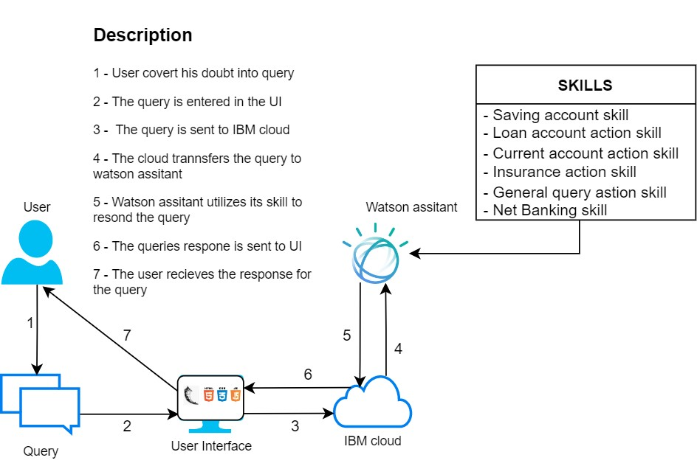

**AI based discourse for Banking Industry**